RECEIVING & EXPORT PROCESS

Supplier Responsibilities

  - Booking Requirement
  - Truck Bill Requirements
  - Cargo Labeling
  - Hazardous Cargo
  - Export Compliance
  - Export Documentation

Booking Requirement

Please follow the following steps when arranging delivery to PressEx Logistics to ensure timely and accurate receipt of cargo.

- Contact PressEx Logistics (via phone or email) before dispatching the trucker and provide the following information.

    - Purchase Order Number
    - Trucker (Delivering Carrier)
    - Tracking Number (Pro#)
    - ETA to PressEx Logistics Miami Warehouse
    - Number of Pieces
    - Cargo weight

* All Shipper’s and Trucking Companies tendering cargo to PressEx Logistics must adhere to our Terms and Conditions. Any Oversize Cargo, Overweight Cargo, Full Truck Loads or More than 10 Pallet or High Quantity of Loose Pieces are subject to an Appointment otherwise cargo is subject to do not be received and PressEx Logistics does not assume any responsibility of additional charges and delays.
Cargo should be delivered in trucks suitable for High-Doc Warehouses (48’H), others are subject to unloading charges, longer waiting times and appointments.

- The PressEx Logistics booking number, if any, should be included in the truck bill, and whenever possible, included in the cargo labeling to ensure the cargo is quickly identified.

- Receiving hours are: Monday – Tuesday – Friday 8:45 AM – 12:00 M / 1:00 PM - 4:45 PM
Wednesday – Thursday 10:45 AM – 12:00 M / 1:00 PM – 4:45 PM

Office hours are: Monday – Friday from 8:30 AM till 5:30 PM

Truck Bill Requirements

Please follow the format when consigning your shipments to PressEx Logistics Miami, to ensure timely and accurate receipt of cargo. The truck bill should include the reference number (booking number) assigned at the booking stage. Consign truck bill of lading as follows:

Ship To:
Customer Name & Destination Country
c/o PressEx Logistics, LLC.
2020 NW 129th Av. Ste 201
Miami, Fl. 33182
Attn: Air or Ocean Export Department
PressEx Logistics Services BK# _________

Request to Shipper or Vendor to correctly mark the cargo per the above “Ship to” instructions, delivering cargo not properly identified or consigned to PressEx Logistics will create delays in identifying the final customer of the cargo, hence late Reporting and Dispatching.

Cargo Labeling

Please ensure your cargo labels have the following information to ensure your shipments are processed and routed correctly.

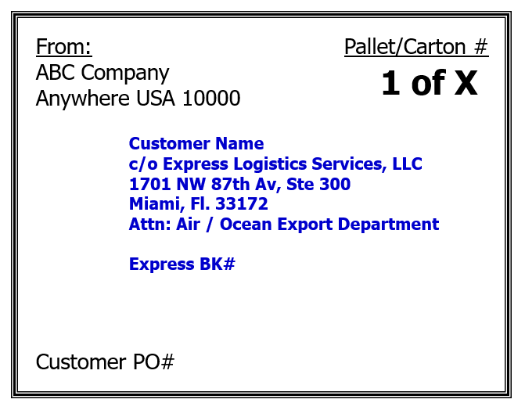
Customer Name & Destination Country
c/o PressEx Logistics, LLC
2020 NW 129th Av, Ste 201
Miami, FL 33182
Attn: Air / Ocean Export Department

Express BK#

Hazardous Cargo

All Hazardous cargo must be accompanied by a material safety data sheet (MSDS) and Dangerous Good Declaration form upon receipt at PressEx Logistics Services. Proper DG declaration for Air or Ocean cargo is mandatory.

PressEx Logistics reserves the right to refuse any Hazardous cargo upon delivery without proper documentation.

Black Shrink Wrapped Pallets with NO Shipping Documents (Commercial Invoice and/or Packing List)

Any Black Shrink Wrapped Pallets received without any Shipping Documents, will be enforced to get inspected and new Wrapping Charge will be assessed to the Party Paying the Freight Charges.

PressEx Logistics Services reserves the right to refuse any cargo upon delivery without proper documentation.

Export Compliance

Compliance is #1 at PressEx Logistics.
Below are compliance facts regarding the US export compliance process.

Responsibilities in an Export Transaction (§30.3 (e))
U.S. Principal Party in Interest (USPPI) Responsibilities:
• Act on his own behalf and file the EEI
• Appoint an authorized U.S. agent to prepare and file the EEI on its behalf
• Provide a power of attorney or written authorization to the authorized U.S. agent
• Make a License Determination
• Retain documentation

Authorized U.S. Agent Responsibilities:
• Obtain the authorization from the USPPI
• Provide transportation data
• Provide the USPPI with export information that it provided as submitted through the AES, if requested
• Retain documentation

Routed Export Transaction (§30.3 (e))
A routed export transaction is a transaction in which the FPPI authorizes a U.S. agent to prepare and file the EEI. While the FPPI will select the U.S. agent, it may give authorization to the USPPI to file the EEI. There are separate responsibilities for the U.S. Principal Party in Interest and authorized agent in a routed export transaction.

Responsibilities in a Routed Export Transaction (§30.3 (e)(1))
U.S. Principal Party in Interest (USPPI) Responsibilities:
• File on behalf of the Foreign Principal Party in Interest (FPPI), if a power of attorney or written authorization is received.
• Provide authorized U.S. agent of the FPPI with specific export and licensing information.
• Upon request, the USPPI can receive a copy of the required export information that was submitted to the authorized U.S. agent to file.
• Obtain a writing from the FPPI (See EAR 758.3)
• Retain documentation

Authorized Agent Responsibilities:
If authorized by the FPPI:
• Obtain a Power of Attorney (POA) or written authorization from the FPPI
• Upon request, provide the USPPI with a copy of the POA or written authorization provided by the FPPI
• Prepare and file the EEI record
• Upon request, provide the USPPI with a copy of the data elements provided by the USPPI

If authorized by the USPPI:
• Obtain a POA or written authorization from the USPPI
• Prepare and file the EEI record
• Upon request, provide the USPPI with a copy of the data elements provided by the USPPI
• Maintain documentation

Please note that PressEx Logistics reserves the right to refuse cargo under the following conditions:

- No properly packed for International Export Shipments.

- Heavy lose items that are not received on pallets and can’t be properly handled by Forklift.

- No properly identified such as:

  - No Courier ID or Customer Number, in case of Courier Cargo.

  - Cargo consigned to a natural person, not a Company, in case of Regular Cargo.

  - Dangerous Cargo received without proper documentation.

Any additional charges incurred due to refusal will be the responsibility of the supplier.

PressEx Logistics will refrain to refuse acceptance of cargo consigned to ourselves but will not accept responsibility for identifying and reporting the cargo on time.

Any additional charges for storage and/other services will be the responsibility of the supplier or customer and PressEx Logistics cannot be held responsible for not being able to identify cargo on time if it is not properly marked as requested previously.

Export Documentation

Below is a list of documents required for export. To ensure your shipments are processed accurately and timely please complete all required fields of information and submit to PressEx Logistics before the trucker arrives to PressEx Logistics , preferably the same day the trucker is dispatched for delivery.

- Commercial Invoice
- Packing List
- Consent to Search for Air Cargo
- Power of Attorney (POA) and/or SLI*
- MSDS & IMO (for Hazardous Cargo)
- All certificates of compliance (if any)

*If the shipment is Low Value (less than $2500 per HTS shipped) the exporter must still provide the license number or NLR statement “No license required” within the invoice, SLI or EEI.

Please consider that processing and/or requesting all the above documents may take up to one (1) full day and it may delay your shipment until the requirement documents are fully received.

Export Forms attached:

Thanks for helping us to be fully compliance and process your valuable shipment in the fastest and smoothly possible way!

PressEx Logistics, LLC
2020 NW 129th. Av. Ste. 201, Miami, FL 33182
Tel +1 305 456 7884
Email: exports.mia@pressex.co

www.pressex.co

